Considering what you have learnt about Multiple Intelligences, learning styles, UDL, and tips for literacy-accessibility, how would you make this piece of communication more literacy-friendly?
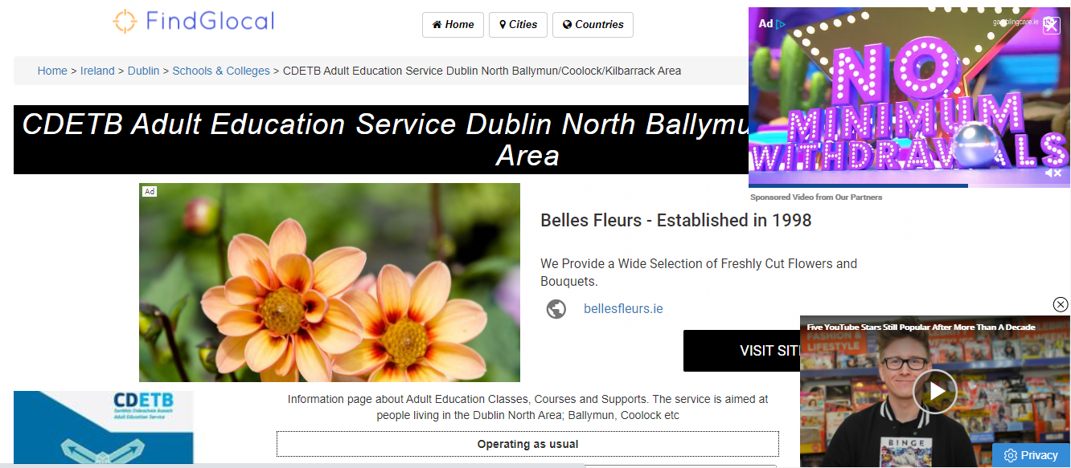

http://www.findglocal.com/IE/Dublin/603772913109444/CDETB-Adult-Education-Service-Dublin-North-Ballymun-Coolock-Kilbarrack-Area

