Zoom - Tips & Tricks

How's your Annotation?
- Find the Annotation tool in Zoom
  - This can look different depending on your device.
  - It may be on the toolbar at the bottom or top of your screen
  - You may need to hit the “More” button to access it
- Choose either Text or Draw or Stamp
  - You can change colour, erase inputs, etc.
- ^{Make your mark}
- Choose ''Clear'' to clear the annotations
  - Clear My Drawings will clear just your drawings
  - Clear All Drawings will clear every drawing on the screen

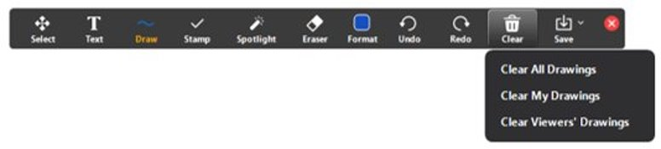
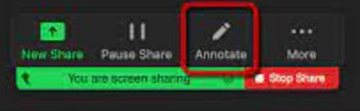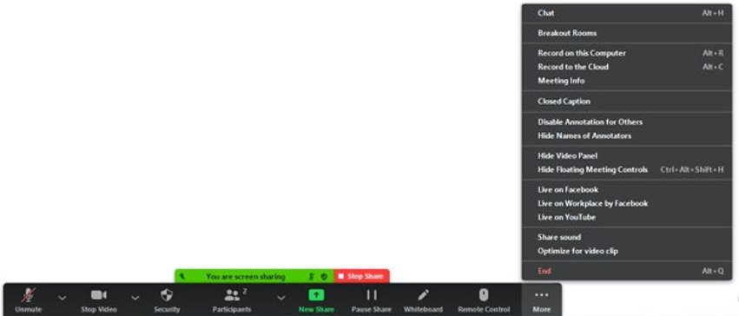
Share Screen & Sound
Share Screen:
- Click “Share Screen” on the toolbar at the bottom of your screen
  - If not visible there, hit the “More” button to access
- Click on the window/tab/whiteboard you want to share (see image)
- Click the blue "share" button

Share Sound:
- Click on "More"
- Choose the option to “Share sound”

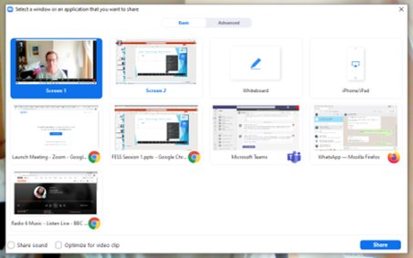
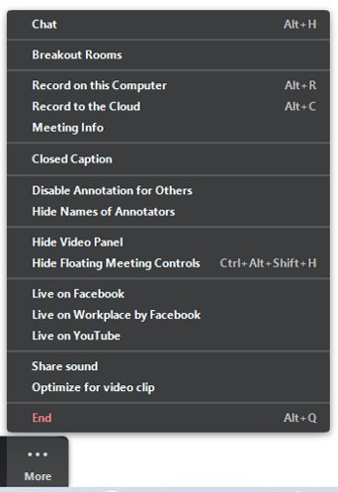

Creating Breakout Rooms
- DON'T PANIC!
- Create Breakout Room by either:
  - Clicking on the Breakout Rooms button on the taskbar, or
  - Going to “More” and choosing the “Breakout Rooms” option
- Add rooms needed (see image 1)
- Assign manually / automatically? (see image 1)
  - Manually means that you assign the participants to specific rooms on the spot – you choose who goes where
  - Automatic means that the rooms will form randomly
  - You can also create the rooms in advance when you are setting up the Zoom, but that’s not usually necessary with smaller groups
- Click on "OPTIONS" to: (see image 2)
  - Set time - this decides how long the room will stay open for
  - Set countdown timer - this will be added on to the end of the time you have set

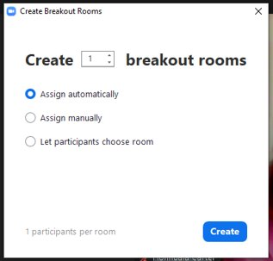 | 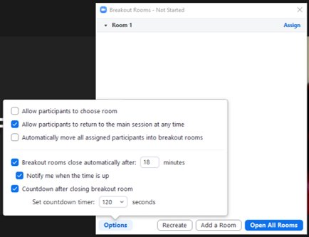
Image 1 | Image 2

When participants are in Breakout Rooms, the presenter can broadcast messages to all rooms. The presenter can also join and leave rooms to check in with participants during a task.

Participants can share their screen and use other tools while they are in the Breakout Room.

On the settings in your Zoom account, it is possible to set automatic recording of session, or that any Whiteboards from session are automatically saved, along with lots more features.

