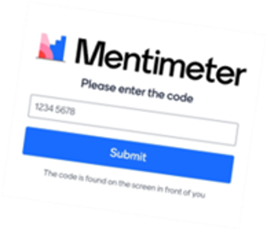
Using Mentimeter.com
The website for presenters and teachers to use is Mentimeter.com.
Participants on a session go to Menti.com.

- Create a free account on Mentimeter.com
  - Free accounts allow 2 slides per presentation – usually plenty for any session
- Create a new presentation
  - Type - choose slide type
    - Multiple Choice, Word Cloud, Open Ended, Scales, Ranking, Q&A
  - Content – insert questions, etc.
- Presenting
  - Choose “Present” on your Menti
  - Share your screen on Zoom
  - Participants can go to Menti.com and enter the code on the screen
- Download Results
  - See the image below. The blue box to the right shows where you can download the Menti results and then reset the presentation for future use.
  - Results can be shared with the group and with course materials.
- Reset Results – you can reuse your presentations

