Microsoft Forms

Within your working Microsoft Team, i.e. not the Class Team – your administration Team:
- Create a new document, choosing ''Forms in Excel'' (Image 1)
- Enter survey questions and options
- In the Form ''Settings'' ensure it is accessible by people outside your organisation (Image 2)
- Share your survey using the Share options in the top right hand corner (Image 3)

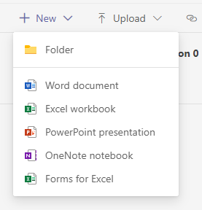 | 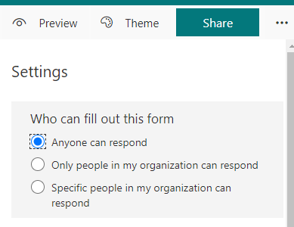 | 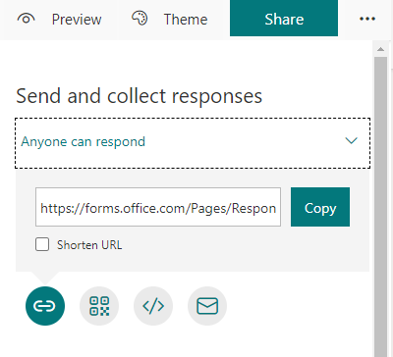
Image 1 | Image 2 | Image 3

