The One to One Approach to Programme Development: Level 3
Below is a graphical representation of the one to one approach to programme development. In this approach a Provider will develop a programme where one programme module maps directly to one component specification. This means that all of the learning outcomes from one component specification are covered in one programme module.

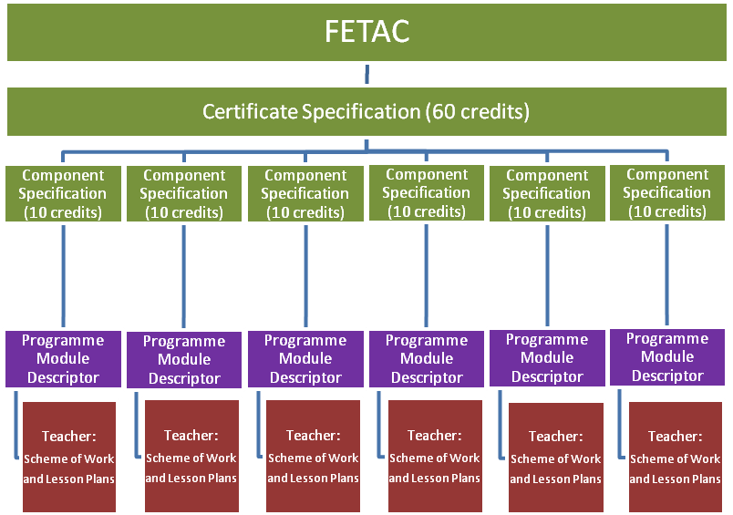
Provider’s Validated Programme

FETAC:

It is the role of FETAC to:
• make and promote awards on the National Framework of Qualifications
• determine standards and award requirements
• validate programmes leading to awards
• monitor and quality assures programmes and services

For further information on FETAC please check out www.fetac.ie

Certificate Specification:
A Certificate Specification is published by FETAC for each named Major Award. At Level 3 there are four named Major Awards and therefore four Certificate Specifications.

There are Certificate Specifications for:
• Level 3 Employability Skills 3M0935
• Level 3 General Learning 3M0874
• Level 3 Information and Communications Technologies 3M0877
• Level 3 Science and Engineering Skills 3M0829

The Major Awards at Level 3 require the Learner to achieve a minimum of 60 credits in order to achieve certification in the Major Award.

Please check out the FETAC website for the Certificate Specifications

Component Specification
AComponent Specification is published by FETAC for each named Minor Award.

A Component Specification is basically a statement of what the Learner should know and/or be able to do and how the Learners should be assessed to demonstrate this knowledge/skill/competence.

At Level 3 the default credit value for a component is 10 credits. There are also components available with a credit value of 5 credits.

In order for a Learner to achieve certification in a Major Award at Level 3, the Learner must achieve a minimum of 60 credits. In this example the Provider has chosen six components with a credit value of 10 credits each.

A Provider may choose more than the minimum and offer the Learner an opportunity to achieve certification in, for example, 7 or 8 components at 10 credits each which would mean the Learner has the opportunity to achieve 70 or 80 credits.

Similarly a Provider may decide to include two components with a credit value of 5 credits each rather than one component with a credit value of 10 credits.

In deciding which components to offer a Learner, the Provider must insure that the certificate requirements are adhered to in terms of which components are compulsory and which are optional for an award. The specific certificate requirements are outlined in the relevant Certificate Specifications.

Validated Programme
A Provider must develop a programme and have this programme validated by FETAC before offering it to the Learner.

This means that a Provider must design and document a learning package which describes how the award standard will be reached by the Learner, how the Learner will be assessed, what supports are available to the Learner and so on.

A Provider cannot offer certification in the new common awards until they have developed this programme and submitted it to FETAC for validation.

Information about developing programmes for validation is available on the FETAC website.

Programme Module Descriptor
Every programme will be divided up into smaller chunks or pieces of learning and these are called programme modules.

In this example each programme module affords the Learner the opportunity to achieve the learning outcomes from one component (Minor Award).

Eventhough this example outlines how the learning outcomes from one component are achieved through one programme module, integration of content and/or assessment can still take place once the programme is being delivered and the Learner assessed.

Teacher
The information in the programme module descriptor will guide the Teacher/Tutor in terms of what content should be covered in his/her classes and how the Learner should be assessed.

In addition to considering the information in the programme module, the Teacher/Tutor should also be aware of the context in which this programmme module fits in terms of the overall programme and the detail included in the application for programme validation.

By referring to the programme information and the programme module descriptor(s), the Teacher/Tutor will be able to develop his/her scheme of work and lesson plans to tailor his/her classes to the specific needs of his/her Learner.

