Appendix
This appendix contains materials to implement a half day equality session, during which the checklists are completed.
The session plan outlines the content for the session. This session has been piloted twice as part of this EMU project, and has been received very positively by participants.

Session plan
PowerPoint Presentation to be used at session (Context)
Equality Quiz
Equality Quiz with answers
Case study Scenarios
Case study Scenarios with best practice examples
Evaluation sheet

Session Plan

Time | Activity | Materials Required
10.00- 10.20 | Introduction to Project  Participants to introduce themselves  Name, Role and length of time in role  Ground rules  Equality quiz  Introduce Case Study scenarios | PowerPoint Presentation  Flip chart  Quiz  Ground rules  Prize  Case Study scenarios
10.20-10.30 | Introduce programme descriptor and programme module checklists | Checklists and copies of programmes and programme modules
10.30-10.50 | In pairs work through checklists applying them to programme and programme module
10.50-11.00 | Introduce Equality Action Planning Framework Checklist | Checklist and copies of framework
11.00-11.30 | In pairs choose a programme module and plan it together using the checklist. Followed by feedback and discussion
11.30 – 11.45 | Break
11.45- 12.15 | Facilitated discussion – feedback on  •How useful were the checklists?  •How practical were they?  •How and when would you use them?  •Suggestions for changes and Amendments | Flipchart for notes
12.15-12.35 | In pairs discuss scenarios and identify three good equality practices which would have prevented these issues from arising
12.35-12.50 | Process- facilitated discussion | At end hand out case studies with additional notes listed
12.50-1.00 | Evaluation | Evaluation sheet

Powerpoint Presentation to be used at Session (Context)
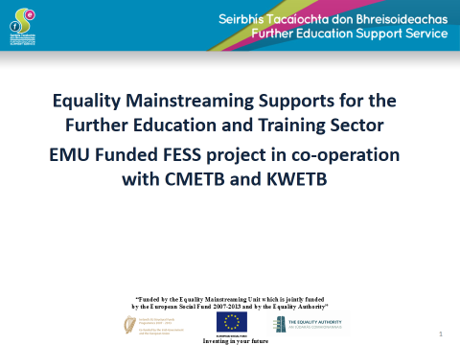

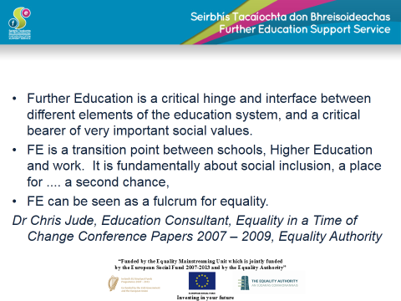

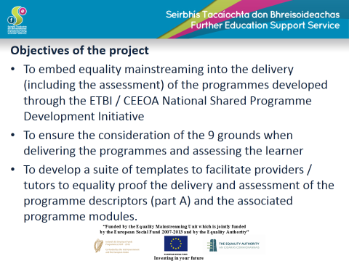
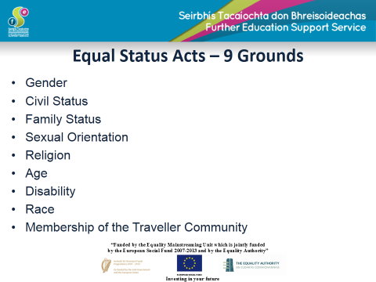

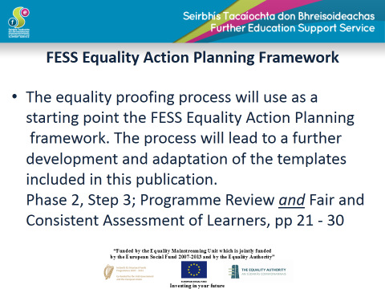
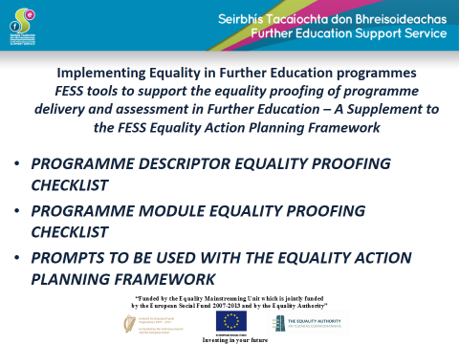

Equality Quiz
- Our Equality Authority is being merged with the Irish Human Rights Commission in 2014. True/False

- Ireland has had equality legislation since we joined the EEC in 1973
True/False

- Ireland has two main pieces of equality legislation - The Employment Equality Act, 1998 and the Equal Status Act, 2000

True /False

- We have an equality officer in our centre so the rest of us do not need to worry about equality issues True /False

- Our ETB has an equality policy True/False

- Name the 9 grounds recognised in our equality law-
- _____________________
- _____________________
- _____________________
- _____________________
- _____________________
- _____________________
- _____________________
- _____________________
- _____________________

- Equality is a good thing, but it is expensive and a bit of a luxury which we can’t really afford as a society.
True/False

- You need to be an equality expert to understand and implement good equality practice. True/False

Equality Quiz – Answers
1. True- The new body will be called the ‘Irish Human Rights and Equality Commission’

2. False - Ireland joined the EEC in 1973. Our first equality legislation was enacted in 1977- see below-
The Employment Equality Agency (EEA) was a statutory body set up under the Employment Equality Act 1977, whose role was to "work towards the elimination of discrimination in relation to employment", to "promote equality of opportunity between men and women in relation to employment" and "to review the workings of the equal pay and equal opportunity legislation and make proposals for their amendment" (Employment Equality Act, 1977 section 35). The Act provided for other functions for the Agency as well: the Agency had power to conduct investigations, power to issue "nondiscrimination notices”, and to assist claimants in bringing cases under the Acts.
The marriage bar -Female civil servants and other public servants (primary teachers from 1958 were excluded from the so-called “marriage bar”) had to resign from their jobs when they got married, on the grounds that they were occupying a job that ‘should go to a man’. Banks operated a similar policy- It was removed in July 1973, on foot of the report of the first Commission on the Status of Women.

3. True

4. Equality is in everybody’s interest. We all have important roles to play in promoting equality.

5. True - All QQI/FETAC Providers must have an Equality policy

6. The Nine grounds are:
- Gender
- Civil status
- Family status
- Sexual orientation
- Religion
- Age (does not apply to a person under 16)
- Disability
- Race
- Membership of the Traveller community.
7. False - There is much evidence to suggest that the more equal a society is, outcomes are better for all. (The Spirit Level)

8. False - We all have an important role in promoting equality. Much of what is good practice in delivery and assessing learning is good equality practice but we don’t necessarily see it as such.

Introduction to Case Studies / Scenarios for Discussions

These case studies/ scenarios were used within the context of the training sessions related to the use of the templates for equality proofing. Individual scenarios were distributed to groups early in the sessions, and subsequently discussed with reference to the pointers for teachers/tutors. They may be used also in a general equality training sessions.

These case studies are based on real life scenarios developed for the training sessions, with further input from the Equality Authority.

The scenarios can be used to stimulate discussion and may allow for issues to be teased out in a group setting.

It is envisaged that these issues will be mostly discussed by teachers/tutors or by teachers/tutors and coordinators together. The main learning objective of the scenarios is to consider the practical implications of making equality a reality.

It is advised that a staff member or an external person with some equality expertise and good facilitation skills will moderate the discussions, or that the discussions should be framed in a wider equality awareness programme.

The discussions should avoid unnecessary generalisations or stereotyping of groups covered under the nine grounds, and should focus instead on finding practical solutions for accommodating diversity and promoting equality in consistency with local policies and the equality legislation.

Please note that the equality legislation covers ‘vocational education and training’ both under the Employment Equality Acts (re: equality in employment) and the Equal Status Acts (re: equality in service provision).

Scenario 1

Jennifer is a student in a beauty therapy course in her local ETB FE College.
When the term began, she was registered as James. She now wishes to be
known as Jennifer, and has begun to dress appropriately for her new
gender identity. However, Jennifer appears to be isolated in the classroom, and
It is possible that other students may not be treating her well. She has
also mentioned to a few people that she feels bullied. She has also
commented that she does not feel accepted by her teachers/tutors.

Scenario 2

Mary is a Traveller who is taking part in a QQI/FETAC Community
Healthcare Course. On Monday she missed a skills demonstration as she
was at a wedding. No provision was made for her to do the skills
demonstration at another time. She feels that she is being discriminated
against.

Scenario 3

Fatima is a Muslim student and wears a Hijab (a veil that covers head and
chest) - occasionally in conjunction with another garment that covers her
mouth and nose. She is doing a QQI/FETAC Communications L5 and has
to do a presentation that will be videoed. Marks are allocated for effective
use of body language and eye contact. Other students in the class think
that she is getting off easy, because of the veil.

Scenario 4

Pavel is a teacher/tutor in a Further Education College. One of his learners
is a fifty-year-old woman who has poor literacy skills. Pavel wants to use
Reasonable Accommodation to facilitate this learner in completion of her
assessments.

Case Studies / Scenarios for Discussions

Pointers for Teachers/Tutors

Scenario 1

Jennifer is a student in a beauty therapy course in her local ETB FE College.
When the term began, she was registered as James. She now wishes to be
known as Jennifer, and has begun to dress appropriately for her new
gender identity. However, Jennifer appears to be isolated in the classroom,
and it is possible that other students may not be treating her well. She has
also mentioned to a few people that she feels bullied. She has also
commented that she does not feel accepted by her teachers/tutors.

Pointers for Teachers/Tutors

Legal
The equality ground relevant to this case is the transgender ground which is protected under the ‘gender ground’. However, transgender people may be also associated with a different sexual orientation, and discriminated both on the ground of gender and on the basis of perceived or real sexual orientation. For further information on the definition of transgender and other related terms see the recent Transgender Equality Network Ireland (TENI) publication STAD: Stop Transphobia and Discrimination Report which provides definitions. The report is available at this link; STAD Report

- Bullying is a serious issue, it should be addressed immediately. Bullying may also include ostracism and exclusion of an individual by another individual or by a group of people. The teacher/ tutor should check whether there is a ‘dignity and respect’ policy which covers bullying and harassment and consider if any action needs to be taken based on the definitions and procedures outlined in the policy.
- Harassment is a form of discrimination covered under the equality legislation and is linked to one or more of the nine grounds of the equality legislation. Under the equality legislation harassment on any of the nine grounds can be a once-off episode and it is against the law. Bullying may or may not be linked to an equality ground but it is not covered by the equality legislation.

Promoting equality and accommodating diversity
- The student is transitioning to her new gender identity and needs support and acceptance.
- The teacher/tutor may contact the Transgender Network of Ireland (www.teni.ie) and ask for advice on how to deal with the situation, or may contact a local transgender organisation. The national organisation BeLongTo (www.belongto.org) may also be able to assist.
- Students and teachers/tutors should be made aware of the existing equality policies, and/or equality statements and dignity and respect policies that are relevant to the inclusive ethos of the institution.
- Staff development sessions/ Continuous Professional Development (CPD) Sessions could provide specific training on transgender issues (preferably through an NGO representing transgender people) or on equality in general.
- A transgender speaker could be invited to speak to the students.
- The college could disseminate materials from NGOs like TENI or BeLongTo, (which also represents transgender youth).
- A teacher/tutor can create time and space for students and other staff to explore issues of isolation and potential discrimination and/or bullying which may arise in the classroom and how they might best be dealt with.
- The college could organise a series of events throughout the year to raise awareness on the equality grounds, the meaning of discrimination and on social exclusion issues.

Policy context checklist
- Does the FET provider have an Equality Policy? (Note: all QQI providers/colleges should have an equality policy and related procedures).
- Is there a Dignity and Respect policy dealing with Bullying and Harassment? (Note: such policy should be in place to comply with the Equality legislation and the Safety, Health and Welfare Act).
- Has the college rolled out equality training for staff and students?
- Have the teachers/ tutors discussed equality and anti-discrimination issues in the classroom with students?

Scenario 2

Mary is a Traveller who is taking part in a QQI/FETAC Community
Healthcare Course. On Monday she missed a skills demonstration as she
was at a wedding. No provision was made for her to do the skills
demonstration at another time. She feels that she is being discriminated
against.

Pointers for Teachers/Tutors

Legal
- The equality ground relevant to this case is the Traveller ground which is protected in the legislation under ‘membership of the Traveller Community’.
- Direct discrimination in the legislation occurs where a person is treated less favourably than another person is, has been or would be treated in a similar situation on any of the grounds, such as membership of the Traveller community.
- Indirect discrimination occurs where a rule or provision which applies to everyone, puts a person covered under one of the nine grounds at a particular disadvantage. The provision may appear on the face of it not to be discriminatory, but its effect or impact might be discriminatory.
- Under the equality legislation, service providers in general (and providers of further education and training) are allowed to provide positive action measures to accommodate diversity for groups that are particularly at a disadvantage.
- Promoting equality and accommodating diversity are essential in preventing claims of discrimination.

Promoting equality and accommodating diversity
- The FETAC Quality Assurance Guidelines stressed the importance of facilitating inclusiveness and diversity in the further education system. The QQI guidelines are also outlining these same standards and values, from admissions to assessment and progression of learners.
- It is unclear whether in this case the student and the teacher/tutor and/or the course coordinator discussed the possibility of re-scheduling the skills’ demonstration, or if there was a formal request from the student. It is unclear if there was a clear policy and guidelines in place regarding completion of course assessments. It is important to have such a policy and guidelines in place which clearly states the rules and the steps that a student can take if an issue arises.
- As this was a skills’ demonstration and not a written assessment, it may have been possible that the student’s request could have been accommodated.
- The participation in this type of family/community event is in general of particular importance in Traveller culture and community, and often requires travelling to other parts of the country. Therefore, it may have been appropriate to do everything possible to accommodate a request to complete the skills demonstration at another time. It may be noted, however, that individual Travellers may have also different views on this issue and therefore similar requests should be considered within the context of each individual request.
- It is possible that in this case, that better dialogue and communication between student and teacher/tutor and/or course coordinator could have led to a more positive outcome for both parties.
- Students and teachers/tutors should be made aware of the existing equality policies, and/or equality statements and dignity and respect policies that are relevant to the inclusive ethos of the institution.
- Staff development sessions/ Continuous Professional Development (CPD) Sessions could provide specific training on Traveller culture (and diversity within it) and on equality in general.
- More awareness should be also raised about the risks of applying policies without flexibility which may give rise to claims of (indirect) discrimination.
- Indirect discrimination may also be affecting individuals under other equality grounds.

Policy Checklist
- Does the FET provider have an Equality Policy? (Note: all QQI providers/colleges should have an equality policy and related procedures).
- Has the college rolled out equality training for staff and students?
- Have the teachers/tutors discussed equality and anti-discrimination issues in the classroom with students?
- Have the teachers/tutors attended training on Traveller culture and general equality issues for the Traveller community in Ireland?
- Were all the students circulated the schedule of various assessments well in advance?
- Was there an application of the ‘Fair and Consistent Assessment of Learners’ standards in this individual case?
- Is there an appeal system through which the student can request a re-scheduling of this specific skill-demonstration?

Scenario 3

Fatima is a Muslim student and wears a Hijab (a veil that covers head and
chest) - occasionally in conjunction with another garment that covers her
mouth and nose. She is doing a QQI/FETAC Communications L5 and has
to do a presentation that will be videoed. Marks are allocated for effective
use of body language and eye contact. Other students in the class think
that she is getting off easy, because of the veil.

Pointers for Teachers/Tutors

Legal
- The equality ground relevant to this case is the Religion ground (which covers religious beliefs, background or none). There are many exemptions around the religion ground. For example, some schools with a specific religious ethos may have the discretion in admission policies or in recruitment procedures to protect their religious ethos. This can include selecting students or employees who will ensure the maintenance of the religious ethos of the schools. However, that is not normally the case for Further Education and Training institutions.
- Direct discrimination in the legislation occurs where a person is treated less favourably than another person is, has been or would be treated in a similar situation on any of the nine grounds.
- Indirect discrimination occurs where a rule or provision which applies to everyone, puts a person covered under one of the nine grounds at a particular disadvantage. The provision may appear on the face of it not to be discriminatory, but its effect or impact might be discriminatory.
- Under the equality legislation, service providers in general (and providers of further education and training) are allowed to provide positive action measures to accommodate diversity for groups that are particularly at a disadvantage.
- Promoting equality and accommodating diversity are essential in preventing claims of discrimination.

Promoting equality and accommodating diversity
- It is important to note that the use of the hijab and of the other veil that covers the nose and mouth, would not pose obvious issues with regard to eye contact and general body language.
- The teacher/tutor may need to clarify in the classroom the definition of body language which will be used for the assessment.
- The teacher/tutor may also need to discuss and clarify further this issue before any conflict or resentment arises in the classroom.
- Framing the discussion from an equality perspective would help provide understanding of everybody’s rights and responsibilities under the equality legislation. This should be done in a sensitive manner, which avoids putting the Muslim student ‘on the spot’.
- The teacher/tutor should avoid at all costs the stereotyping of Muslim women in particular, as there is a great diversity among them, especially around the use of the hijab and other garments. These are generally worn as a symbol of modesty.
- Staff development sessions/ Continuous Professional Development (CPD) Sessions could provide specific training on religious diversity (and diversity within it) from an equality perspective.
- Awareness-raising event on the nine grounds or on religious diversity in particular, could be organised by teachers/tutors and other staff, in collaboration with students.
- Students and teachers/tutors should be made aware of the existing equality policies, and/or equality statements and dignity and respect policies that are relevant to the inclusive ethos of the institution.
- The FETAC Quality Assurance Guidelines stressed the importance of facilitating inclusiveness and diversity in the further education system. The QQI guidelines are also outlining these same standards and values, from admissions to assessment and progression of learners.

Policy Checklist
- Does the FET provider have an Equality Policy? (Note: all QQI providers/colleges should have an equality policy and related procedures).
- Has the college rolled out equality training for staff and students?
- Have the teachers /tutors discussed equality and anti-discrimination issues in the classroom with students?
- Have the teachers/tutors attended training on religious diversity from an equality perspective?
- Was it explained to all the student what is a ‘Fair and Consistent Assessment of Learners’ and how it applies in this type of situation?

Scenario 4

Pavel is a teacher/tutor in a Further Education College. One of his learners
is a fifty-year-old woman who has poor literacy skills. Pavel wants to use
Reasonable Accommodation to facilitate this learner in completion of her
assessments.

Pointers for Teachers/Tutors

Legal
- The equality ground which may or may not be relevant to this scenario is the disability ground. Under the equality legislation this ground would apply only if the learner’s low literacy skills are obviously related to a learning difficulty, or an intellectual disability, or another type of disability. In the majority of cases, low literacy skills are linked instead to early educational disadvantage and not to disability. In order to ascertain if reasonable accommodation applies a decision needs to be made with the learner as to whether the poor literacy skills are a result of a disability or not.

- In the equality legislation, there is strong obligation to provide reasonable accommodation for learners with disabilities; reasonable accommodation involves putting in place supports or facilities or arrangements that would enable a person with a disability to fully access, participate and advance in further education.

- Disclosure of a disability may be difficult for a learner and therefore any information disclosed should be used and stored in accordance with the Data Protection Act.

- The teacher/tutor may need to ascertain also whether low literacy skills may be linked to another ground even if the disability ground does not apply and reasonable accommodation is not required. Under the equality legislation ‘positive action’ (measures to accommodate diversity for groups that are particularly at a disadvantage) is also allowed to support groups across the grounds that are particularly at a disadvantage, e.g. the race ground, in case the learner’s first language is not English. Please also note that Sign Language speakers often have Sign Language as a first learnt language and English as a second language.

Promoting equality and accommodating diversity
- Promoting equality and accommodating diversity may go beyond the scope of the nine grounds of the equality legislation. Socio-economic status is not a protected ground under the equality legislation, but discrimination on this basis may nonetheless exist, although it may not have a form of legal redress under the equality legislation.
- It is unclear in this scenario as to what are the root causes of low literacy skills for this specific individual learner.
- It is possible that disability, another ground and/or socio-economic disadvantage may play a role in this case.
- FET providers often have literacy supports for their learners.
- There may be a need, however, to develop specific literacy supports for people with different kinds of disabilities or learners whose first language is not English, etc.
- If the learner does not have a disability but the root cause of low literacy can be linked to another of the grounds, the teacher/tutor may offer different kinds of supports, in the spirit of ‘positive action’ (measures to accommodate diversity for groups that are particularly at a disadvantage).
- In the event that the root cause of low literacy cannot be linked to any of the grounds and therefore does not fall within the scope of the equality legislation e.g. socio-economic status, it is still good equality practice to provide supports.

Policy Checklist
- Does the FET provider have an Equality Policy? (Note: all QQI providers/colleges should have an equality policy and related procedures).
- Has the college rolled out equality training for staff and students?
- Has there been any specific disability training rolled out for teachers /tutors?
- Does the FET provider have a reasonable accommodation policy for students and a procedure to implement it (as per QQI’s ‘Fair and Consistent Assessment of Learners’ policy?
- Has there been an initial assessment of the learners to identify literacy difficulties early on and were appropriate referrals /supports offered?
Evaluation Sheet
Please circle words that reflect how you found the session:

Interesting Food for thought Confusing Useful

Easy Enjoyable Stimulating Boring Complicated

Uninteresting Fun Practical Difficult Time went quickly

Well organised Exciting Learned a lot Surprising

Badly organised Uncomfortable

Please rate the activities you took part in today-

 | Very good | Good | OK | Poor
Quiz
Checklist 1
Checklist 2
Case studies

Would you be likely to use the checklists for programme planning? Yes/ No

Would you use the checklists for programme review? Yes/No

If you were going to use the checklists when would you do so?
____________________________________________________________________________________________________________

Will you use anything else you learned from the session today? If so what and how? ____________________________________________________________________________________________________________

Any Other Comments? ______________________________________________________
______________________________________________________
_________________________________________________________________________________________________Thank you!

