Process
Items: 5 Steps
Duration: 25 seconds
Filename: C:\Documents and Settings\administrator.TEACHANLEINN\Desktop\NewWebsite\AssessmentL12\Process.intr

Step 1
5 seconds
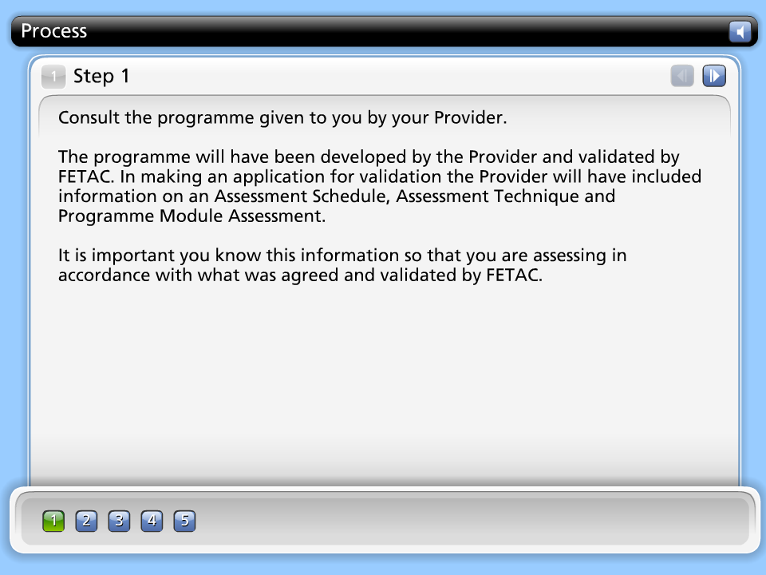

Step Text
Consult the programme given to you by your Provider.

The programme will have been developed by the Provider and validated by FETAC. In making an application for validation the Provider will have included information on an Assessment Schedule, Assessment Technique and Programme Module Assessment.

It is important you know this information so that you are assessing in accordance with what was agreed and validated by FETAC.

Step 2
5 seconds
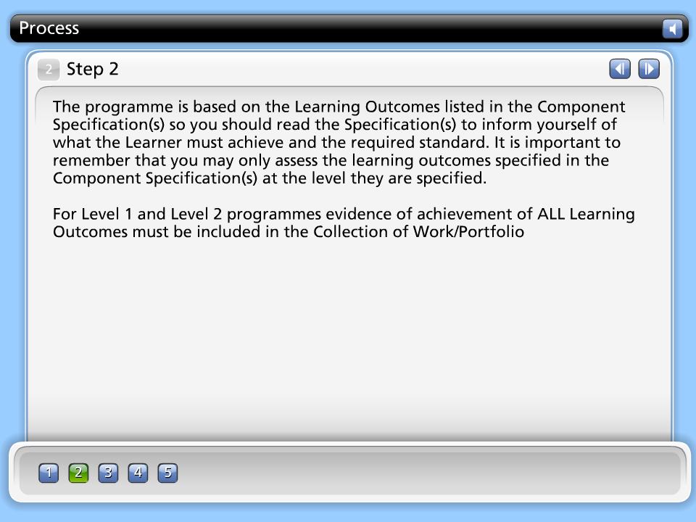

Step Text
The programme is based on the Learning Outcomes listed in the Component Specification(s) so you should read the Specification(s) to inform yourself of what the Learner must achieve and the required standard. It is important to remember that you may only assess the learning outcomes specified in the Component Specification(s) at the level they are specified.

For Level 1 and Level 2 programmes evidence of achievement of ALL Learning Outcomes must be included in the Collection of Work/Portfolio

Step 3
5 seconds
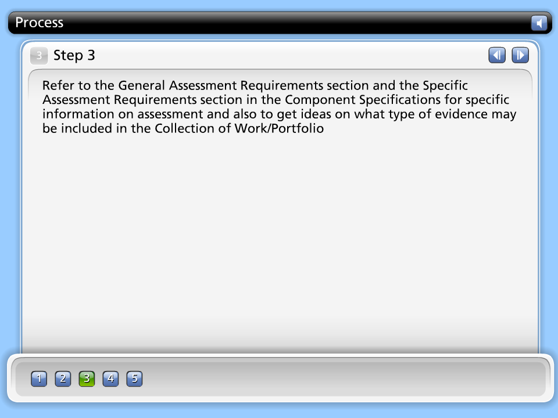

Step Text
Refer to the General Assessment Requirements section and the Specific Assessment Requirements section in the Component Specifications for specific information on assessment and also to get ideas on what type of evidence may be included in the Collection of Work/Portfolio

Step 4
5 seconds
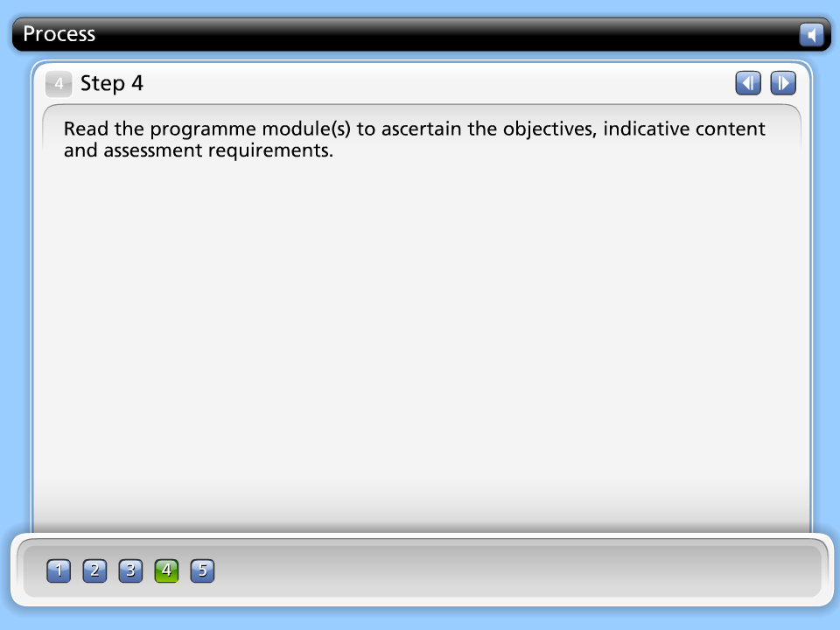

Step Text
Read the programme module(s) to ascertain the objectives, indicative content and assessment requirements.

Step 5
5 seconds
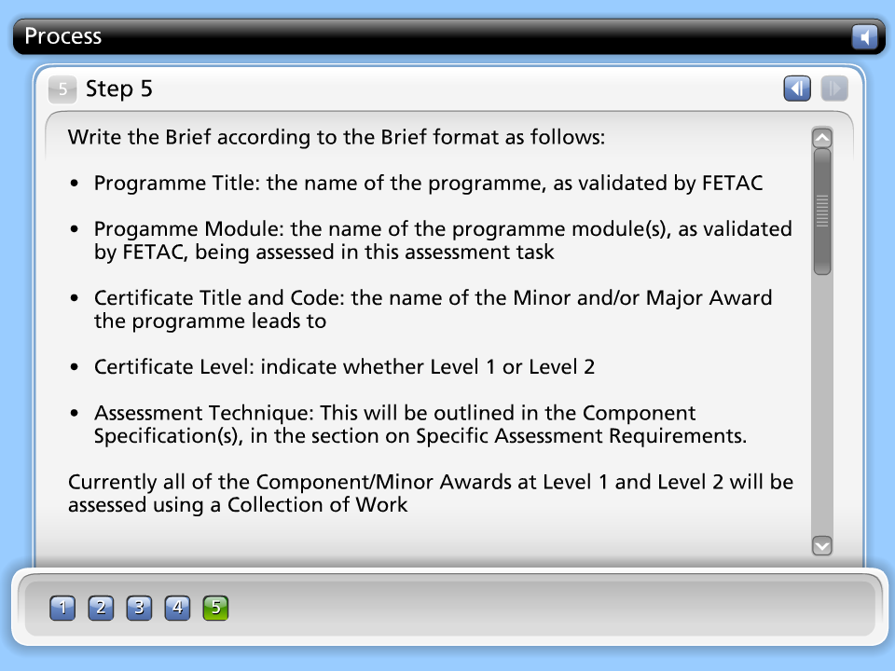

Step Text
Write the Brief according to the Brief format as follows:

• Programme Title: the name of the programme, as validated by FETAC
• Progamme Module: the name of the programme module(s), as validated by FETAC, being assessed in this assessment task
• Certificate Title and Code: the name of the Minor and/or Major Award the programme leads to
• Certificate Level: indicate whether Level 1 or Level 2
• Assessment Technique: This will be outlined in the Component Specification(s), in the section on Specific Assessment Requirements.
Currently all of the Component/Minor Awards at Level 1 and Level 2 will be assessed using a Collection of Work
• Title: (Optional) reflect the topic of this piece of assessment evidence
• Guidelines: outline what the Learner is required to do. These should be detailed guidelines on how to complete this piece of assessment. The guidelines will have to be associated with the learning outcomes being assessed as it is the learning outcomes that will guide you about the level and the kind of knowledge, skill and competence the Learner should be demonstrating in the piece of assessment. The guidelines may allow for the assessment of one learning outcome, a range of learning outcomes from one Component Specification or a range of learning outcomes across a number of Component Specifications.
Some examples of how guidelines may be worded are:
• Based around the activity of shopping, the Learner will choose three Christmas presents for family members. In choosing these presents the Learner will demonstrate the following.........
• Based around the activity of sending a text message, the Learner will use his mobile phone to communicate with a friend and organise an outing for next weekend. In completing this task the Learner will ............
• Based around the activity of using public transport to get from your home to your school, the Learner will ..........

• Learning Outcomes Assessed : list the learning outcomes from the Component Specification(s) that are being assessed with this assessment task. As the Assessor you will need to tease out what each learning outcome means in terms of what standard the Learner will achieve at this level and how s/he will evidence this standard. This teasing out may have already been done when the programme was written, before being submitted to FETAC for validation, therefore it is important to ensure you are familiar with all information pertaining to the validated programme prior to assessing the Learner.

In this section of the brief, by listing the learning outcomes being assessed in the assessment task, it will make it easier for the External Authenticator to confirm that the standard has been reached by the Learner and to confirm that all learning outcomes are evidenced in the Learner's Collection of Work

• Date: Optional

