TEL Tools to support Online Teaching and Learning

Teaching and learning activity | Useful Tools | How it works | Links
Introducing new topics  Formative assessment  Tip: If you create an ‘open class’ students will not need to sign-up. They simply use a code provided by the teacher to access the lesson. | Edpuzzle | This is a web application that enables teachers to easily embed questions and quizzes into existing videos/YouTube clips at any point. You can also add voiceover, audio notes or even crop the video to suit your class group. Students also have the option to re-watch before answering a question. Excellent tool to check students understanding and to track whether they are watching your lessons. | https://telms.eu/wp-content/uploads/2018/12/TELMS-Edpuzzle-A-Quick-%E2%80%9CHow-To%E2%80%9D-Guide-for-Teachers.pdf
Create a tutorial  Tip: Can be embedded in Moodle, Canvas, Microsoft Teams and Google Classroom | ScreenCast-O-Matic | This is a digital recording of a computer screen output (video screen capture software) that can be used to create video from your screen that contains audio narration. Great tool to teach Microsoft office for example. | https://www.youtube.com/watch?v=K3wqlKDnWv0&feature=youtu.be  FESS resource
Facilitating discussion, brainstorming and collaboration | Padlet | An online noticeboard, which means it can be used for making announcements, keeping notes and online brainstorming. Padlet can be used by students and teachers to post notes on a common page. The notes posted by teachers and students can contain links, videos, images and document files. When registered with Padlet, one can create as many “walls” or online notice boards as you like. Great tool for posting homework/study tasks. | https://jn.padlet.com/
Group or project work | Google Docs | A web-based application in which documents and spreadsheets can be created, edited and stored online for free. Google docs is compatible with most presentation and word processing applications and lends itself to collaborative projects in which there are multiple authors working from geographically diverse locations. Users have control over who sees their work and all participants who can subsequently see the document are privy to see who and when specific alterations were made.
Video conferencing, Webinars | Zoom | This tool for videoconferencing and screen sharing has extended its capabilities included in the free licenses to support schools and businesses affected by coronavirus. For example, it allows you to host an unlimited number of video meetings with up to 100 participants. | https://support.zoom.us/hc/en-us/categories/200101697
Storage of materials, assessment; plagiarism checker, assignment submission and grading | Moodle | Moodle is an open-source software learning management system which aims to help educators, administrators and learners to create personalised learning environments. It has a simple interface and drag-and-drop features that make it easy to use.

Screencast-o-matic Screencasting Software (Free Version)
Step 1: Create an Account with Screencast-o-matic
- Go to the Webpage https://screencast-o-matic.com/
- Click the Sign-up button in the top right corner of the page.
- Enter your email address and click the blue Sign-up button.
- Check your email for the link Screencast-o-matic sends you. (If you don’t get the email in a couple of minutes, check your junk mail folder.)
- Click the link or copy and paste it into your browser.
- Fill in your name and password on the registration page.
- Tick the box to agree to the terms of service.
- Click the Create Account button. 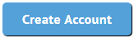

Step 2: Download the recorder and install it on your computer.
- Click the Download Install button on the main Screencast-o-matic screen.
- Save the file to your computer.
- Click Yes to install the recorder.
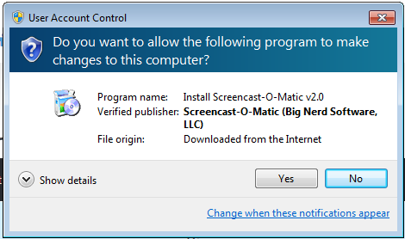
- Follow the steps on the Screencast-o-matic Set-up Wizard.
- When the Wizard is finished, click the Finish button.
- Click the Launch Free Recorder button.
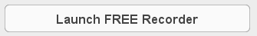
- Close the Recorder for now by clicking the Cancel button.
Step 3. Open the file that you want to record over (e.g. PowerPoint presentation)
- Navigate to the file that you are using to present and open it on screen.
  - For this tutorial, open the presentation that you brought along for the workshop.

Step 4: Plug in you microphone/headset.
Step 5: Start the Recorder
- From the main screencast-o-matic webpage, click the Start Recorder button.
- Click to allow or OK if prompted.
  - In Chrome, the prompt looks like this:
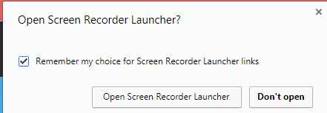
  - Tick the ‘Remember my choice’ box so you don’t have to allow the launcher every time you open it.
  - If you are not prompted to allow the recorder in the browser, click the button to download the recorder to your computer.
Step 6: Resize the frame of the recorder around your presentation
- The recorder appears on your screen as a black and white frame with a menu for the recorder controls.
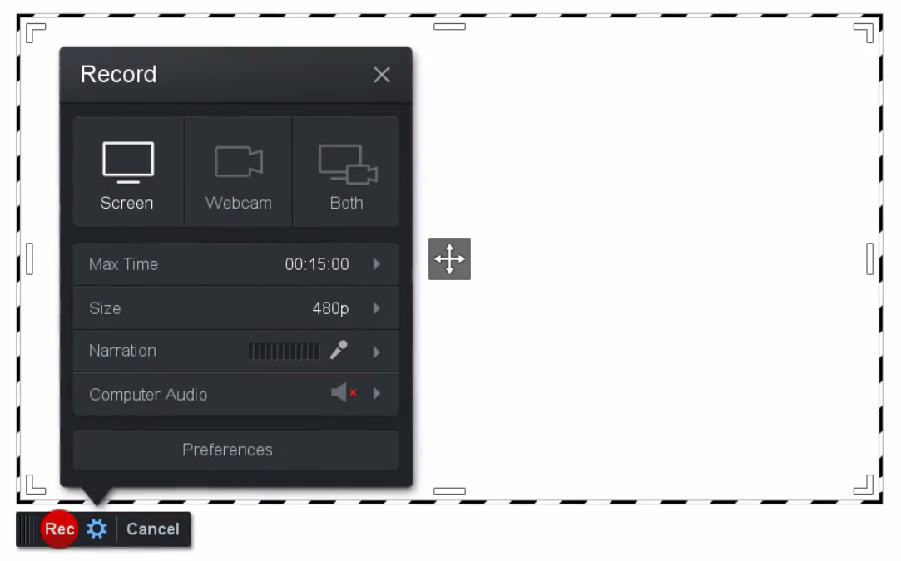
- Drag the recording frame around on the screen by holding your pointer over the crosshairs in the middle or the frame. Click and drag the frame where you want it to go.
- Resize the recorder using the corners of the frame to surround the area that you want to record.
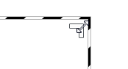
Note: The free recorder has a max time limit of 15 minutes per recording. If you upgrade to a Pro account, you have unlimited recording time. (At only $18 a year, it’s a pretty good deal!)

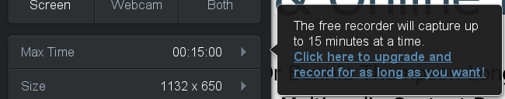
Step 7: Choose what you want to record
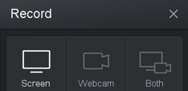
- You can choose to record just your screen, just your webcam, or both.

Step 8: Choose your microphone
- Choose the microphone you want to use to record your voice. (If you don’t choose a mic, it will use the default mic on your computer, which might not give you the best audio.)
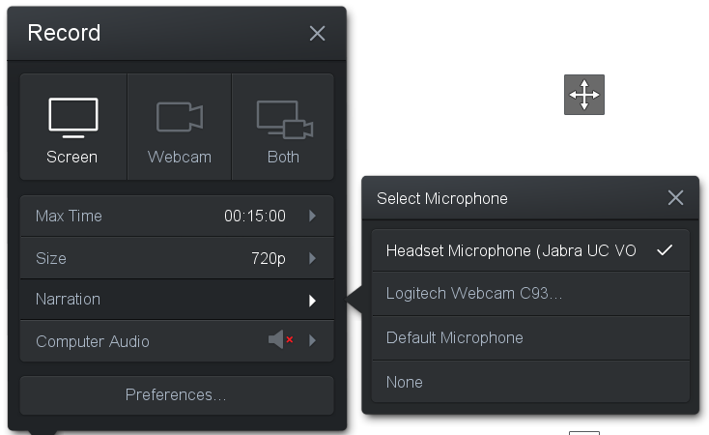
- You can do a Test Playback to make sure the mic is working.
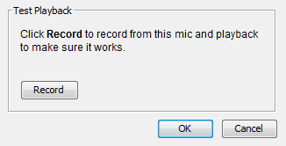
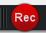
Step 9: Start recording
- Click the red Record button to start recording.
  - All of the action inside the frame will be recorded.
- If you are recording a PPT presentation, click the slideshow button in the bottom right corner of the screen - - to put the presentation into slideshow view.
- Proceed with your presentation. Screencast-o-matic will record your voiceover and whatever is on screen within the red and white frame.
- While you’re recording, you’ll see a red pause button in the bottom left corner of the recording frame. Click this to pause during your recording.
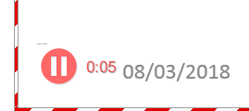
- To continue recording, click the Rec button.
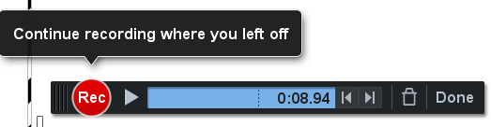
- To stop recording, click the red pause button.
- To preview the recording click the play button.
- If you don’t like what you’ve recorded, you can delete this recording and start over by clicking the delete button.
- If you’re happy with the recording, click the Done button.
Step 10: Save the video to your computer
- You will be prompted to save the video to your chosen location.
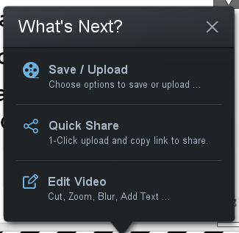
  - Click the Save/Upload button.
  - Click the Save as Video File option to save the video to your own computer.
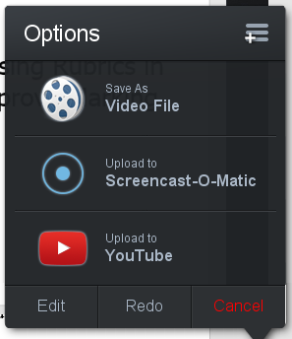

- In the Filename section the video has been given a generic name.
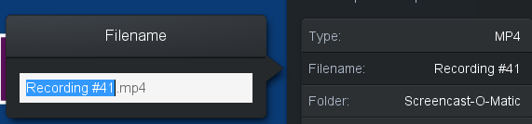
  - Click in the Filename section. In the window that opens, delete the generic name and give the video a descriptive title.
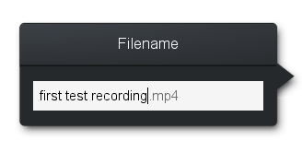
- Click on Folder and choose Browse to navigate to the folder where you want to save the video.
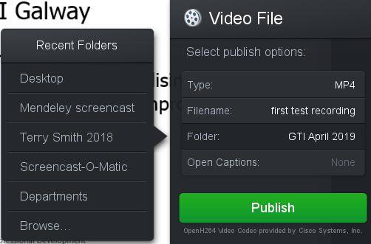
  - Click Publish. While the video is publishing, you can stop the process if you want.
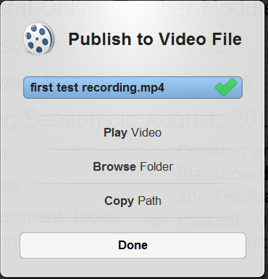
  - When the publishing process is finished, click the Done button.

*************************************************

Editing your Screencast
The free version of Screencast-o-matic doesn’t include editing. (The pro version is only $18 a year, which is a fantastic deal if you want to upgrade your own account to pro!)
If you’re using your own pro account, you can edit your video before you save it, by clicking the Edit button in the save Options window:
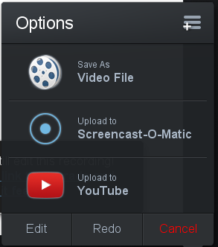
Alternatively, you can upload a video you saved to your own computer and edit it here.

We can try out the Video Editor for free for 30 days no, so let’s do that for now.
- Click the Open Video Editor button at the top of the screen on the Screencast-o-matic Website.
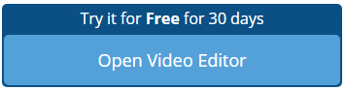
- Click the Start my 30 -Day Trial button.
- Click the Continue Demo button.
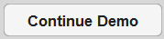
- In the top right corner, click the Import button at the top right side of the screen.
- Navigate to the folder where you saved the video earlier.

- Select the video file and click Open.
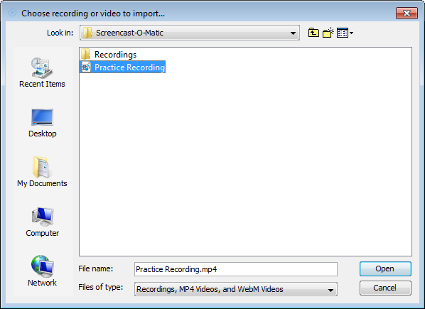
- In the Screencast-o-matic window, double click the video file to open it and click the Edit button.
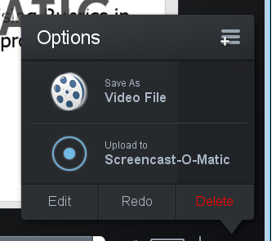
- At the bottom of the editing window, you can see the timeline of your video.
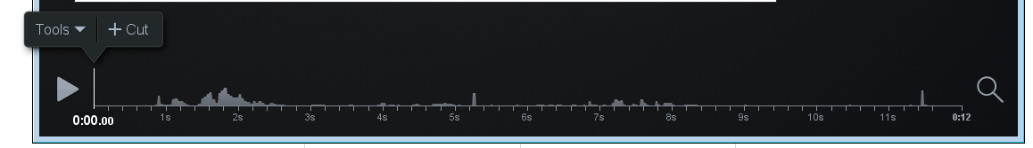
- Click the Play button to play the video.
Delete (cut) a section of the video:
- Click where you want to start your cut.
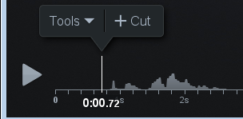
- Click the Tools menu button above the timeline and select the Cut tool.
(The last used tool will be listed next to the Tools button above the timeline.)

- Select the section to cut by dragging the red bar forward or backward along the timeline. (I dragged this backward to the beginning of the timeline.)
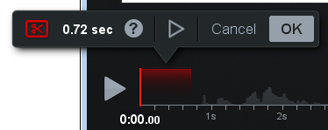
  - The section to be cut is highlighted in red.
  - You can click the little preview button to preview what the track will be like with the cut.
  - If you’re happy with what will be cut, click OK. If not, click Cancel and try selecting the section you want to cut again.
Try out the other tools:
- Hold your cursor over each tool. A screen-tip pops up to tell you what you can do with each tool.
  - Some of the tools have sub-menus. Hold your cursor over these too, to see what you can do with them.
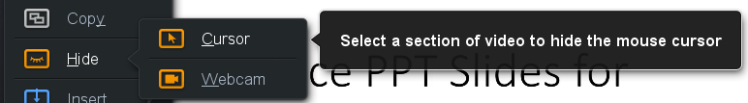
*************************************************
For further assistance with Screencast-o-matic editing tools, use the Help button in the top right corner of the screen to access video tutorials on all aspects of the program.
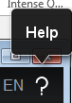
Screencast-o-matic Pro Editing Tools
 | Select a section of video to cut
 | Select a section of video so you can use it with Insert Paste
 |  | Select a section of video to hide the mouse cursor
 |  | Select a section of video to hide the webcam
 |  | Make a new recording and insert it into this recording
 |  | Insert a copy of an existing recording into this recording
 |  | Insert a pause to hold the video, audio, cursor, webcam at a certain point in this recording
 |  | Insert an MP4 video file into this recording
 |  | Insert a copy made using the copy tool
 | Select a section of video to narrate over
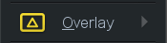 |  | Allows you to add an image overlay to your video
 |  | Allows you to blur out sections of your video
 |  | Allows you to add an outline shape (oval or rectangle) to a section of your video
 |  | Allows you to add an arrow shape to point to something on your video
 |  | Allows you to highlight a section of your video, greying out the rest of the video so the highlighted part stands out
 |  | Allows you to enter a text box on your video
 |  | Select a section of video to replace with a new recording
 |  | Select a section of video to replace by freezing the video frame
 |  | Select a section of video to speed up
 |  | Select a section of video to slow down
 | Add a transition to the video at this point
 | Select a section of video to adjust volume levels

